**--- Main Menu ---**

**1. Sign Up**

**User-2**

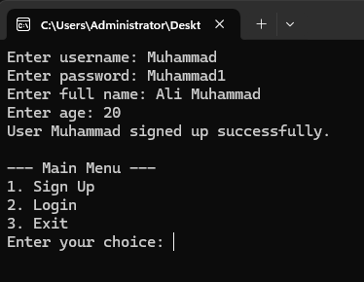

**User-1**

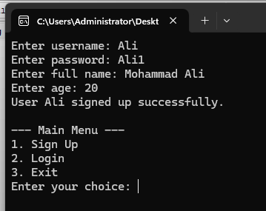

**2. Login**

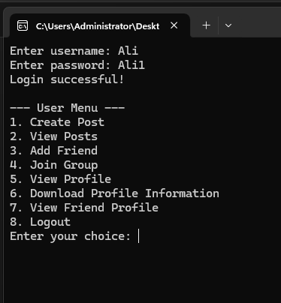

**3. Exit**

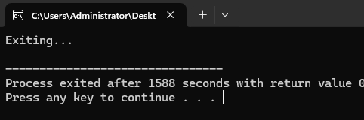

**--- User Menu ---**

**1. Create Post**

**View Profile after like and comment**

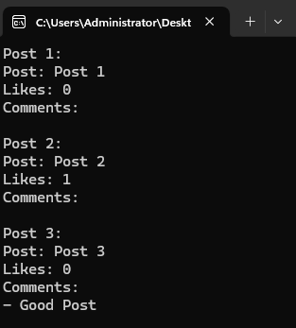

**2. View Posts**

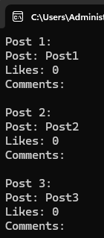

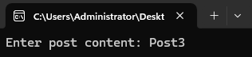

**3. Add Friend**

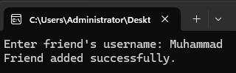

**4. Join Group**

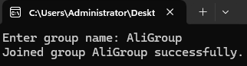

**5. View Profile**

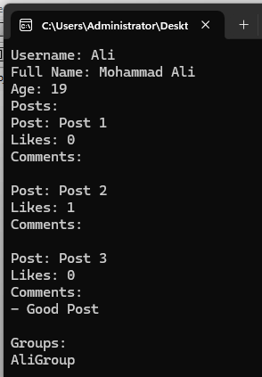

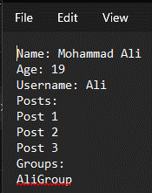

**6. Download Profile Information**

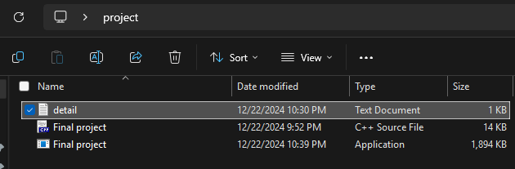

**7. View Friend Profile**

**8. Logout**

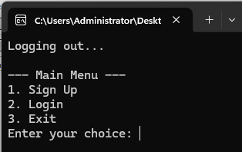

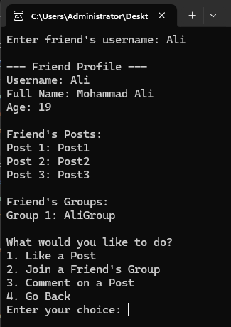

**--- Friends Profile ---**

**1. Like Post**

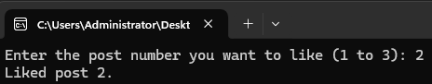

**2. Join a Friend’s Group**

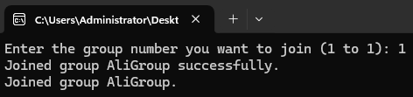

**3. Comment on a Post**

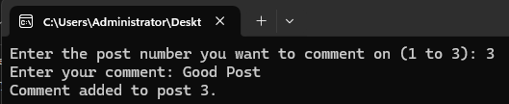

**4. Go back (to User Menu)**

**GitHub link:**

[**https://github.com/MuhammadAliAly/Project-2-Final.git**](https://github.com/MuhammadAliAly/Project-2-Final.git)